**Code Guide**

M. Pourfard, K. Faez, “[A Statistical Approach for the Characterization of Self-Assembled Hexagonal Lattices](https://www.sciencedirect.com/science/article/pii/S0169433212011786),” Applied Surface Science, 2012 [**IF=6.182****] [**[**Q1**](https://www.scimagojr.com/journalsearch.php?q=28983&tip=sid&clean=0)**] [**[**PDF**](https://www.researchgate.net/publication/257031948_A_statistical_approach_for_the_characterization_of_self-assembled_hexagonal_lattices)**]**.

If you have used the code you must cite the above paper.

Code Language: MATLAB

Date of code: 2012

Producer: Mohammadreza Pourfard

Email: [pourfardm@gmail.com](mailto:pourfardm@gmail.com)

**How to run the code?**

1. Run the guide command in matlab
2. select browse button to choose the image (e.g. 1-1-2-.tif)
3. Press run Moving average (press the button)

The code is embedded in guide version but if you want to run the non-guided version please run the **corelation_hexagonal.m** code.

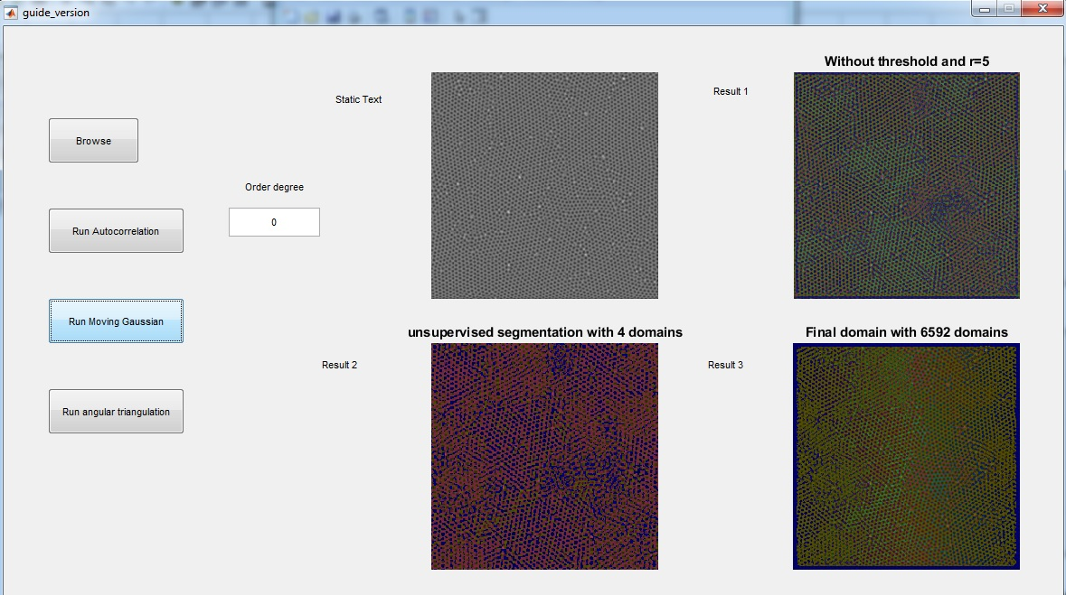

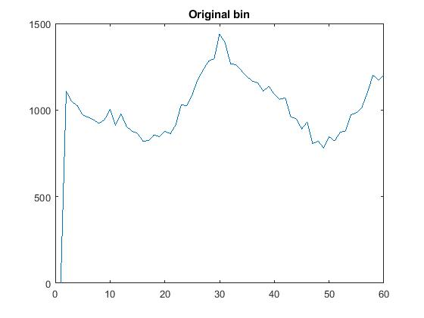

Figure 1 is the orientation of the pores

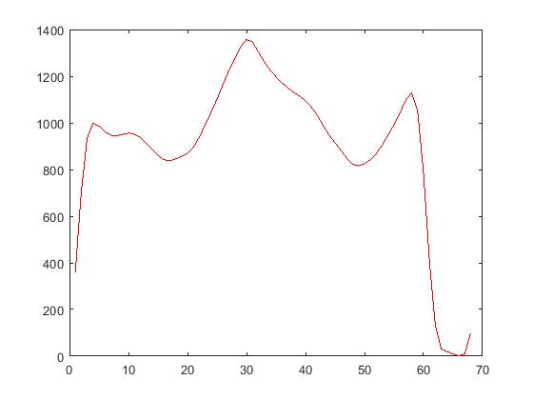

Figure 2 is the smoothed version of figure 2

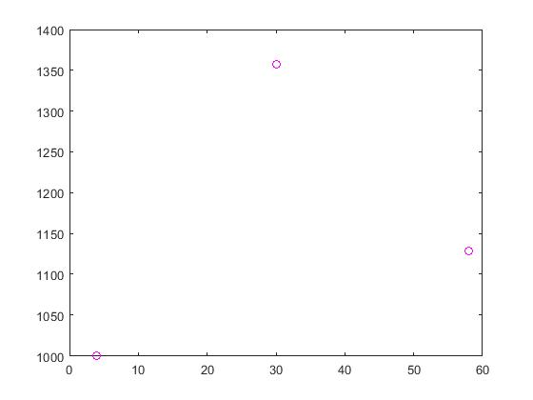

Figure 3 is the peaks’ place of the figure 2

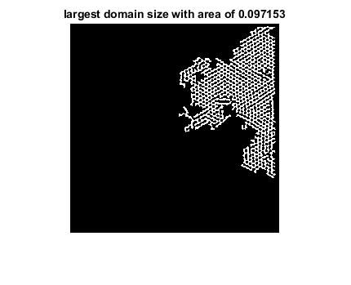

Figure 4 is the largest domain